A Comparative Study of Stand-Alone and Hybrid CNN Models for Malaria Parasite Detection

Dr. C.N. Aher - Professor, Department of Computer Engineering

AISSMS Institute of Information Technology, Pune

email@aissmsioit.org

Aditya Bhalerao

AISSMS Institute of Information Technology, Pune

Pune, Maharashtra, India

adityab7968@gmail.com

Arpit Bora

AISSMS Institute of Information Technology, Pune

Pune, Maharashtra, India

arpitbora14@gmail.com

Jayashri Ghorpade

AISSMS Institute of Information Technology, Pune

Pune, Maharashtra, India

jayashrighorpade18@gmail.com

Sumedh Gole

AISSMS Institute of Information Technology, Pune

Pune, Maharashtra, India

sumedh11.sg@gmail.com

**Abstract—Malaria, a life-threatening mosquito-borne disease, contributes to a significantly high number of fatalities in tropical/subtropical regions due to inadequate detection technology, lack of laboratory experience, and other challenges. Malaria detection presents a critical challenge in regions with limited resources. In this study, we propose a novel approach utilizing deep learning (DL) models for feature extraction and machine learning (ML) algorithms for prediction. Specifically, we explore combinations of convolutional neural networks (CNN) for feature extraction with random forest (RF), k-nearest neighbors (KNN), and support vector machine (SVM) classifiers for prediction. We devised custom CNN architectures to extract features, which were then fed into ML classifiers for prediction. Our approach aims to enhance**

**malaria parasite detection accuracy, particularly in resource-limited settings, by leveraging the strengths of DL for feature extraction and ML for prediction.**

**Keywords: Malaria detection, Deep learning, Machine learning, Convolutional neural networks (CNN), Random forest (RF), k-nearest neighbors (KNN), Support vector machine (SVM), ResNet50, Feature extraction, Hybrid models, Prediction, Resource-limited settings, Parasite dataset, Accuracy enhancement, Custom CNN architectures**

**I. INTRODUCTION**

Malaria remains a prominent issue in global health, especially in areas where advanced medical resources are scarce. Swift and precise identification of malaria parasites is vital for efficient treatment and control of the disease. Infected mosquitoes spread the parasite to humans through their bites. The majority of malaria instances happen in developing nations, predominantly in Sub-Saharan Africa. Each year, over 290 million individuals contract malaria, resulting in over 400,000 deaths. [1] Malaria diagnosis involves examining red blood cells. To detect malaria, centrifugal machines separate red and white blood cells, allowing only red blood cells to be analysed through blood films. Blood smears are a common laboratory test used for malaria diagnosis. [2] Rapid diagnostic tests (RDTs) serve as the primary method for diagnosing malaria across all healthcare sectors and in field settings. However, the accuracy of these antigen-based diagnoses through RDTs may be compromised due to the emergence of deletions in parasite antigen genes, as indicated in recent global literature. [3,4] Conversely, the scarcity of highly skilled expertise in microscopy and the extended time required to read blood smears for precise malaria parasite detection make it exceedingly challenging to utilise in rural and remote areas. This obstacle impedes the diagnosis and treatment of malaria on a large scale. Parasitologists often operate in resource-constrained settings without robust systems to maintain their skills or ensure diagnostic quality. This situation frequently results in inaccurate diagnostic outcomes and consequently inappropriate treatment. For instance, false positive results from diagnostics lead to unnecessary administration of antimalarial drugs and subsequent side effects like abdominal pain and nausea. Conversely, false negative diagnoses prompt unnecessary antibiotic use, additional consultations, and the potential escalation of severe malaria cases. [5]Hence, the creation of an automated malaria diagnosis system stands as an attractive research objective for enhancing personalised patient care and management.

Deep learning possesses the capability to autonomously discern crucial features from extensive datasets, thereby generating precise outcomes. This technology is rooted in neural networks, which emulate the functions of the human brain, enabling analysis and learning through the input of perceptual data into intricate deep neural networks. Deep learning using feature extraction and machine learning for prediction can be used to differentiate between malaria parasite infected cells and non-infected cells. Despite the evolving technologies, the actual accuracy also depends on the dataset being used. Recent progress in deep learning has revealed that convolutional neural networks (CNNs) can achieve higher accuracy in image classification compared to humans across various objects. [6]

In this paper, we undertake a comparative analysis of various machine learning models. Specifically, we focus on evaluating the performance of CNN-KNN, CNN-Random Forest, CNN-SVM, and ResNet models. Through systematic experimentation and evaluation, we aim to elucidate the strengths and weaknesses of each model in addressing the task at hand. By leveraging these diverse methodologies, we strive to provide valuable insights into the efficacy of different machine learning approaches.

**II. LITERATURE SURVEY/RELATED WORK**

[7]This work investigates the use of deep learning techniques in medical imaging, with a particular emphasis on the analysis of red blood cell pictures for the purpose of diagnosing malaria. A major obstacle is the lack of malaria datasets, even with deep learning's potential in this field. Furthermore, large training datasets and intricate algorithms are required to precisely identify the tiny, hazy infected areas in cell pictures. The research suggests a neural network training strategy that highlights the important infected pixel regions that are essential for malaria cell classification. This approach is inspired by human reading patterns. The suggested approach dramatically improves classification accuracy across a range of model complexities, including Resnet and Mobilenet designs, according to tests carried out on the NIH malaria dataset. Remarkably, the suggested method surpasses the 94.49% classification accuracy of the baseline model with a 97.2% accuracy.The study also offers a perceptive regularization analysis of weight parameter magnitudes, which adds to the evidence supporting the usefulness of the suggested approach in malaria cell classification tasks.

[8]This work discusses the critical process of automating the analysis of whole blood cell counts, which is necessary for evaluating general health and identifying a range of illnesses, including leukemia, anemia, and infections. Through the use of convolutional neural networks (CNNs) on blood smear images, our goal is to decrease treatment costs and speed up diagnosis. We also concentrate on finding malarial pathogens in blood samples. According to experimental results, the system consistently recognizes photos infected with the malarial parasite with a mean average precision higher than 0.95 when compared to ground-truth data. Furthermore, the program is modified for quick prototyping on a cheap microcomputer.

[9] This article discusses the persistent challenge of malaria in rural and remote regions of tropical countries, emphasizing the importance of early diagnosis and effective treatment for reducing mortality and morbidity associated with the disease. While Rapid Diagnostic Tests (RDTs) are commonly used alongside clinical assessments and blood film microscopy, concerns have arisen regarding RDT accuracy and the practicality of microscopy in resource-limited settings. To address these challenges, there's a pressing need for advanced and efficient diagnostic tools, particularly to enhance the reliability of malaria microscopy.Drawing on the success of deep learning methods in image analysis tasks, the paper proposes a novel approach to improve the performance of deep learning models in pathogen detection on microscope images of thick blood smears. The proposed method involves consistently labeling ground truth bounding boxes to train custom deep learning architecture (YOLO-mp), optimized for accuracy and speed with minimal resource requirements. The developed YOLO-mp models, particularly the three-layered (YOLO-mp-3l) and four-layered (YOLO-mp-4l) variants, demonstrate superior mean Average Precision (mAP) scores compared to the standard YOLOv4 model when tested on a public dataset of thick blood smear microscope images captured using a phone camera. Moreover, the YOLO-mp models outperform YOLOv4 in terms of computational and memory efficiency, making them suitable for deployment on low-resource devices. Recommendations are also provided for testing the reliability and repeatability of the trained models.

[10] This study investigates whether it is possible to use cellphones to automatically detect malaria parasites in thick blood smears. The first of its type, the suggested approach makes use of deep learning algorithms that can operate on smartphone platforms. The methodology consists of two primary steps: first, a customized Convolutional Neural Network (CNN) is used to classify each candidate as either background or parasite. This is done after an intensity-based Iterative Global Minimum Screening (IGMS) is used to quickly identify parasite candidates in thick smear images. A dataset including 1819 thick smear photos from 150 patients is made publically available for research purposes along with this study. The deep learning technique outlined here is trained and tested on this dataset. The outcomes demonstrate how well the modified CNN model performs in differentiating between positive (parasitic) and negative image patches based on a variety of performance criteria derived from five-fold cross-validation across patients. AUC (Area Under the Curve) (98.39% ± 0.18%), accuracy (93.46% ± 0.32%), specificity (94.33% ± 1.25%), precision (94.25% ± 1.13%), sensitivity (92.59% ± 1.27%), and negative predictive value (92.74% ± 1.09%) are some of these measurements. The suggested method's practicality and reliability are confirmed by high correlation coefficients above 0.98 between automatically discovered parasites and ground truth, both at the picture and patient levels.

[11] In order to identify contaminated cells, this research presents a VGG-based model and compares it with other models that are already in use. When compared to its predecessors, the model performs better across a range of accuracy criteria. One significant benefit is that it is built using comparatively few layers, which saves processing time and computer resources.The paper also assesses the model's performance on two different datasets and highlights the difficulties that present deep learning techniques have in accurately differentiating between polluted and infected cells. It highlights how, in order to improve diagnosis accuracy, questionable regions must be examined more thoroughly.

[12] In order to forecast malaria outbreaks in the Buhera region, this study used logistic regression, decision trees classifier, support vector machines, and random forest classifiers. The results show that when using environmental risk variables for prediction, logistic regression performs better than other machine learning classifiers, with an accuracy of 83%, precision of 82%, and an F1-score of 90%. By giving priority to locations with high malaria incidence, these models provide insightful information to decision-makers, aiding in the efficient use of resources, the creation of early warning systems for malaria, and the optimization of indoor residual spraying tactics.

**III. STAND-ALONE CNN MODEL VS. HYBRID MODELS**

In this study we have conducted several experiments to investigate the abilities of stand-alone CNN and hybrid models to efficiently and accurately detect Malaria in patients. This section presents the datasets and methodologies used in our study.

**1. Dataset**

As aforementioned, one of the challenges that researchers have faced in previous studies is the limited repository of Malaria datasets. In this study, we utilised Giemsa-stained thin blood smear slide images obtained from 150 patients infected with P. falciparum and 50 healthy individuals at Chittagong Medical College Hospital in Bangladesh. The data is published by the National Library of Medicine (NLM) and are accessible in [13]. Cells containing Plasmodium parasites are designated as positive or parasitized. In thick blood smear microscope images, numerous overlapping cells with varying orientations and ambiguous morphological features like shape, colour, and size of blood cells make it challenging to distinguish malaria parasites from artefacts compared to thin blood smears. The number of parasites on an image indicates the severity of infection in a blood sample. With deep learning-based object detection methods, not only the objects can be localised in images but also their number can be counted. [14] The dataset used in this study encompasses 27,560 images stored in JPEG format. These images are divided into two distinct folders: "Infected," housing 13,780 images of Giemsa-stained red blood cells infected with the Plasmodium falciparum parasite, and "Uninfected," containing an equal number of images depicting uninfected red blood cells. Each image within the dataset maintains a resolution of 2988 x 5312 pixels.

To capture the images, cells infected with P. falciparum were observed under a conventional light microscope at Chittagong Medical College Hospital, Bangladesh. Subsequently, these cells were photographed using a smartphone camera. This dataset offers valuable insights into malaria parasite detection and serves as a critical resource for developing and evaluating models aimed at improving diagnostic accuracy in malaria diagnosis.

*Infected cell images*

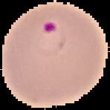 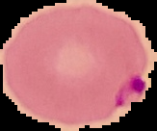

*Non-infected cell images*

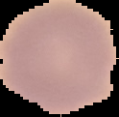 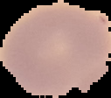

**2. Preprocessing**

For preprocessing purposes, we employed augmentation techniques. These techniques enhanced the robustness and generalization capabilities of our model by augmenting the image samples.The preprocessing steps included:

**Rotation**: Images were randomly rotated within a range of 20 degrees to simulate variations in orientation.

**Width** **Shift**: A maximum width shift of 0.1 was applied to the images, allowing for horizontal displacement.

**Height** **Shift**: Similarly, a maximum height shift of 0.1 was applied to introduce vertical displacement.

**Shear** **Range**: Images underwent shear transformations within a range of 0.1, introducing deformations to the image geometry.

**Zoom** **Range**: Random zooming was applied to images within a range of 0.1, enabling variations in image scale.

**Horizontal** **Flip**: Images were horizontally flipped with a probability of True, diversifying the dataset by mirroring.

**Fill** **Mode**: The 'nearest' fill mode was employed to handle pixel values outside the image boundaries during transformations.

**Validation** **Split**: A validation split of 0.2 was applied, allocating 20% of the dataset for validation purposes to assess model performance during training.

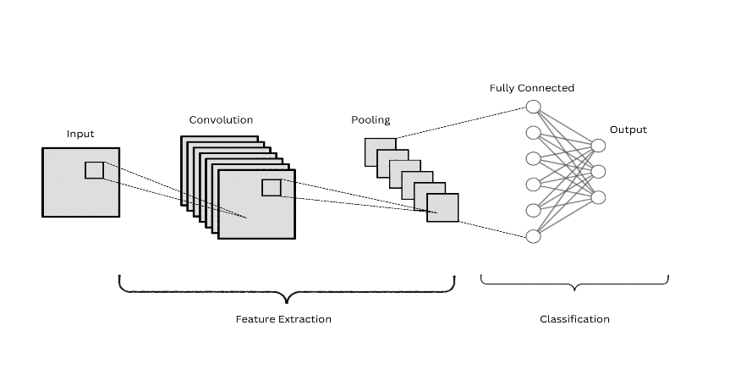This preprocessing pipeline contributed to the generation of a more diverse and representative dataset, thereby enhancing the model's ability to effectively learn and generalize patterns from the input images.

**3. Stand-alone CNN Model**

For our study, we developed a stand-alone CNN model to distinguish between Infected cells and Non-Infected cells

Convolutional neural networks, also known as (CNN), are a specialized kind of neural network used in the computer vision field that contributes to automatic feature extraction and data processing with a known grid-like topology. The CNN architecture has three main layers: convolutional layer, pooling layer, and fully connected layer [15].

The main components of CNN architecture are illustrated in Fig. 2.

**Convolutional layer :** This layer applies several filters to the input to generate feature maps [15].

**Pooling layer :** This layer reduces the size of feature maps in terms of reducing the internal dimensions. Max pooling and average pooling are the two operations available in this layer [15].

**Fully connected layer :** This layer is also called the dense layer. In the fully connected layer, the inputs are connected to the output with a learnable weight and are assigned to the final outputs [15].

**Activation function :** This is a function used to facilitate knowledge of difficult and complex patterns. It includes sigmoid, tanh, and Rectified Linear Unit (ReLU). The most common is the corrected linear unit (ReLU) [15].

[16]

In this research paper, we experimented with a convolutional neural network (CNN) architecture tailored for image classification tasks. The model comprises multiple layers designed to efficiently extract hierarchical features from input images, enabling robust and accurate classification.

The network begins with a series of convolutional layers, each equipped with rectified linear unit (ReLU) activation functions, facilitating the detection of various visual patterns and features within the input data. Subsequent max-pooling layers reduce spatial dimensions while preserving essential information, contributing to translation invariance and computational efficiency. Batch normalization layers are incorporated to stabilize and accelerate training by normalizing layer activations. To mitigate overfitting, dropout layers are strategically inserted, randomly deactivating neurons during training to encourage feature generalization. The network concludes with fully connected layers, which include a sigmoid activation function at the output layer for binary classification tasks, ensuring output probabilities are bounded within the range [0, 1] for binary classification.

i. Convolutional Layer:

- Input: \( X \) (input feature map)

- Filter: \( W_k \) (filter weights for the \( k \)th filter)

- Bias: \( b_k \) (bias term for the \( k \)th filter)

- Output: \( Y_k = \text{ReLU}(X * W_k + b_k) \)

ii. Max Pooling Layer:

- Input: \( X \) (input feature map)

- Pool size: \( P \times P \) (pooling size)

- Stride: \( S \) (stride)

- Output: \( Y_{i,j,k} = \text{max pool}(X)_{(i \times S + m), (j \times S + n), k} \)

iii. Flattening:

- Input: 3D tensor from the last pooling layer

- Output: Flatten the 3D tensor into a 1D vector

3.2 Model summary

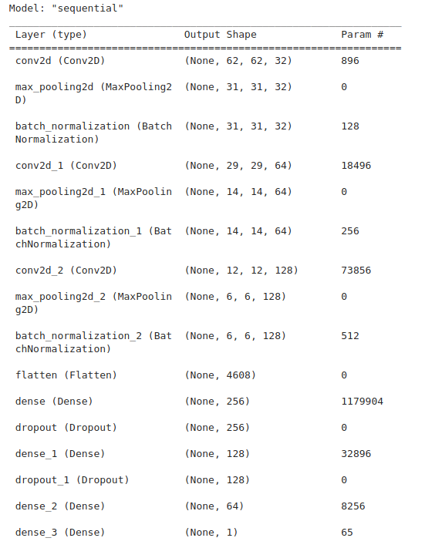

3.3 PARAMETERS OF OUR STAND-ALONE CNN MODEL

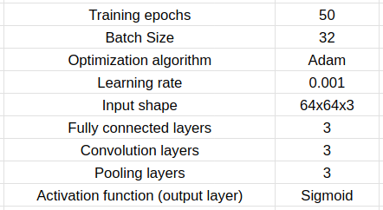

These parameters remain the same for all hybrid models as well.

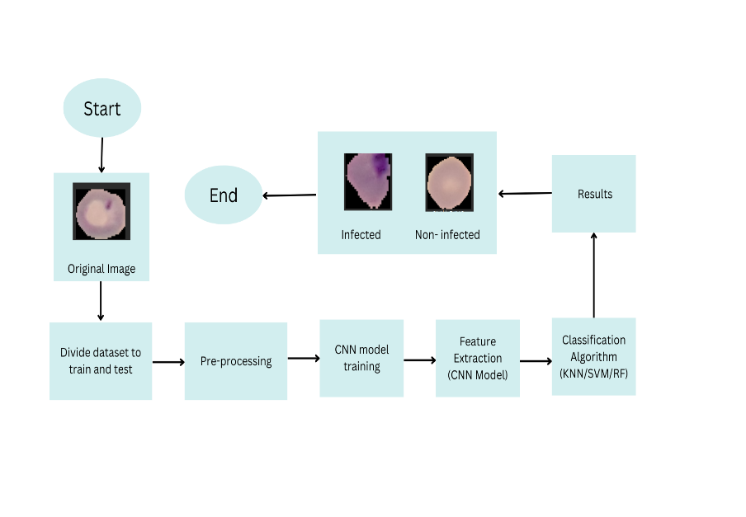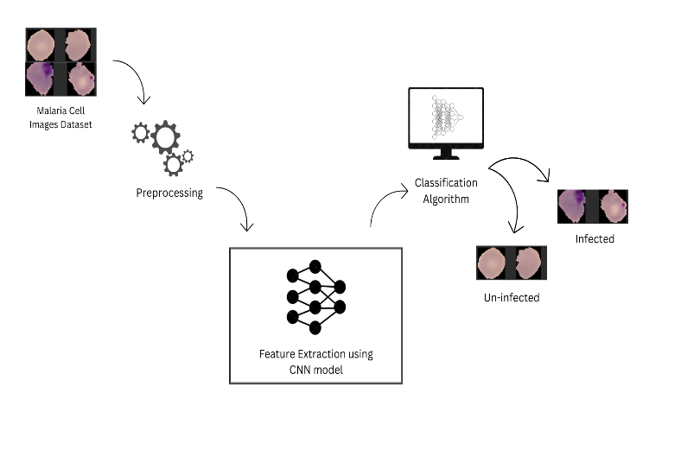**4. Hybrid Models**

In addition to the stand-alone CNN model, we have developed three hybrid models. Each model consists of a CNN architecture for feature extraction and one of the following classification algorithms for classification: K - Nearest Neighbours (KNN), Support Vector Machine (SVM), Random Forests (RF)

A brief description of the selected classification algorithms follows:

K-Nearest Neighbors (KNN): KNN is a non-parametric classification algorithm that classifies a data point based on the majority class of its k nearest neighbours in the feature space. [26]

Support Vector Machines (SVM): Essentially, SVM is a classification algorithm which tries to find the plane that separates the classes with the widest margin in the sample space in the most convenient way [26].

Random Forest (RF): RF is a collective classification and regression algorithm that uses decision trees as a classifier. Each decision tree is trained using a random data set derived from the original data set. The majority voting is used for the final classification [26].

In our approach to building a hybrid model, we initially trained a convolutional neural network (CNN) model as detailed in the previous section, utilizing pre-processed images. Subsequently, we identified and utilized the last max pooling layer, positioned after all convolution layers, for feature extraction purposes. To address dimensionality concerns, a flatten layer was incorporated following the max pooling layer. It's important to note that our usage of CNN 16 primarily focused on feature extraction rather than classification; hence, we omitted the fully connected and softmax layers typically found after the flatten layer. Leveraging these extracted features, we proceeded to train various classification algorithms, including K-nearest neighbours (KNN), support vector machine (SVM), and random forest (RF).

**4.1 KNN Integration:**

The first hybrid model explored in this study integrates a CNN with a KNN classifier. The CNN serves as a sophisticated feature extractor, transforming raw image inputs into a high-level feature representation, which is then used by the KNN algorithm for classification. KNN classifies new instances based on the majority vote of the nearest neighbours in the feature space, making it intuitive and straightforward in its decision-making process.

The KNN classifier uses the extracted features to classify images based on the majority vote from the 'k' most similar instances (neighbours) in the training set. The distance between feature vectors determines similarity.

This model capitalizes on the CNN's ability to learn complex spatial hierarchies in images and the simplicity and non-parametric nature of KNN. Given its reliance on distance metrics to determine neighbour proximity, KNN's performance is significantly enhanced when operating on the distilled feature space generated by the CNN, potentially leading to improved accuracy in image classification tasks.

**4.2 CNN-SVM Hybrid Model**

The second model in our comparative analysis pairs the CNN with an SVM classifier. After the CNN extracts features from the images, the SVM is employed to classify these features into the respective categories. SVM is known for its effectiveness in high-dimensional spaces and its ability to model non-linear decision boundaries through the use of kernel functions.

For the SVM model, the extracted features are input into SVM classifiers with different kernels (linear, polynomial, and RBF) to investigate their performance. SVM works by finding the hyperplane that best separates the features into two classes, with kernels allowing for complex, non-linear separations.

In this study, SVM models with different kernels (linear, polynomial, and radial basis function (RBF)) are evaluated to ascertain their compatibility with the CNN-extracted features. This combination is particularly promising for image classification tasks as it leverages the SVM's robust classification capabilities, especially in scenarios where the decision boundary between classes is not linearly separable.

SVM Output:

- Input: \( X_{\text{flattened}} \) (flattened feature vector)

- Output: \( Y = \text{SVM}(X_{\text{flattened}}) \)

**4.3 CNN-Random Forest Hybrid Model**

The final hybrid model examined integrates a CNN with a Random Forest classifier. Similar to the previous models, the CNN is utilized to extract features from images, which are then classified using Random Forest. Random Forest, an ensemble learning method, consists of a multitude of decision trees and outputs the class that is the mode of the classes predicted by individual trees.

The Random Forest classifier receives CNN's features and employs multiple decision trees to make its predictions. The final classification is determined by averaging the predictions of all the trees, reducing the risk of overfitting and providing a measure of importance for each feature in the classification task.

This model benefits from Random Forest's ability to handle high-dimensional data and its resilience to overfitting, making it a compelling counterpart to CNN's feature extraction. Moreover, Random Forest's capacity for parallel computation allows for efficient handling of the complex features extracted by the CNN, potentially enhancing the model's classification accuracy and scalability.

Random Forest Output:

- Input: \( X_{\text{flattened}} \) (flattened feature vector)

- Output: \( Y = \text{RandomForest}(X_{\text{flattened}}) \)

This layered approach, combining a sophisticated feature extractor with a traditional classifier, leverages the strengths of both deep learning and machine learning methodologies to enhance the model's predictive accuracy and efficiency in image classification tasks

**5. RESULTS AND DISCUSSION**

**A. Performance Metrics**

We used various evaluation metrics to evaluate the proposed models. These metrics are as follows:

**Confusion matrix:** This is a technique that summarizes the performance of the classifier used. It presents true positive (TP) and true negative (TN) values, which means the number of correctly rated positive and negative instances. It also shows false positive (FP) and false negative (FN) values, which means the number of misclassified negative and positive instances [28].

**Accuracy:** Accuracy is the percentage of the test set instances that are correctly classified by the classifier. Accuracy = TP + TN / TP + FN + TN + FP

**Sensitivity (Recall):** Recall is also referred to as the true positive rate, which means the proportion of positive cases that are correctly identified. Sensitivity = TP / TP + FN

**Specificity:** This is the true negative rate. It refers to the proportion of negative instances that are correctly identified. Specificity = TN / TN + FP

**Precision:** Precision is defined as the proportion of the true positives against all the positive results (both true positives and false positives). Precision = TP / TP + FP

**F1 score:** It represents the harmonic mean between recall and precision values. F1score = 2 × Precision × Recall / Precision + Recall

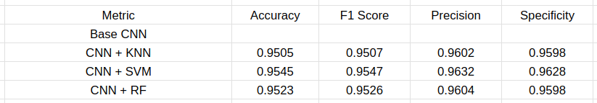**B. RESULTS**

SVM -

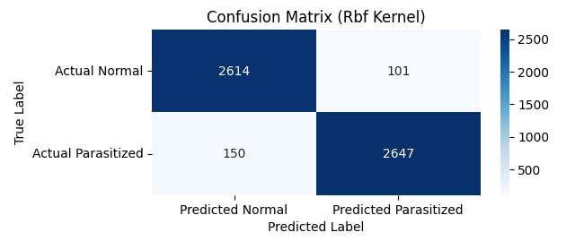

KNN -

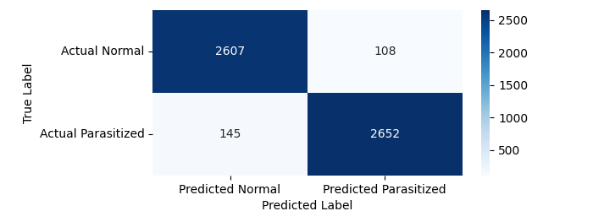

RF -

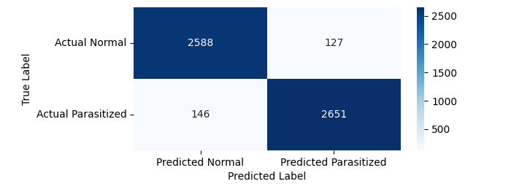

**V. CONCLUSION**

****Several of the problems with the conventional Malaria disease detection test methodology were resolved in this study. It made use of machine learning to boost the effectiveness and quicken the Malaria disease detection procedure. We looked at how well hybrid machine learning models and standalone CNN models detected the illness. In this paper, we suggested a unique method that uses machine learning (ML) algorithms for prediction and deep learning (DL) models for feature extraction. In particular, we investigated the use of random forest (RF), k-nearest neighbors (KNN), and support vector machine (SVM) classifiers in conjunction with convolutional neural networks (CNN) for feature extraction and prediction.

*Model comparisons*

Our findings illustrate that all of the three proposed models are effective in detecting the Malaria parasite. The lowest detection accuracy recorded was 95.05%, which corresponds to the CNN+KNN model's accuracy. The highest accuracy is recorded of the CNN+SVM model with 95.45% accuracy. The most reliable model is the CNN+SVM model with 95.47% F1 Score. The highest precision is also of the CNN+SVM model with 96.32%. The CNN+SVM model tops in the number of negative records correctly predicted with the Specificity percentage of 96.28%.

**VI. REFERENCES**

[1] L. M. Barat, A. Mills, S. Basu, N. Palmer, K. Hanson, and E. Worrall, ‘‘Do malaria control interventions reach the poor? A view through the equity lens,’’ Amer. J. Tropical Med. Hygiene, vol. 71, pp. 174–178, Aug. 2004

[2] S. Sankaran, M. Malarvel, G. Sethumadhavan, and D. Sahal, ‘‘Quantitation of malarial parasitemia in Giemsa stained thin blood smears using six sigma threshold as preprocessor,’’ Optik, vol. 145, pp. 225–239, Sep. 2017.

[3] D. Gamboa, M.-F. Ho, J. Bendezu, K. Torres, P. L. Chiodini, 952 J. W. Barnwell, S. Incardona, M. Perkins, D. Bell, J. McCarthy, and 953 Q. Cheng, ‘‘A large proportion of P. falciparum isolates in the Amazon 954 region of Peru Lack pfhrp2 and pfhrp3: Implications for malaria rapid 955 diagnostic tests,’’ PLoS ONE, vol. 5, no. 1, p. e8091, Jan. 2010. 956

[4] M. Gendrot, R. Fawaz, J. Dormoi, M. Madamet, and B. Pradines, ‘‘Genetic 957 diversity and deletion of Plasmodium falciparum histidine-rich protein 2 958 and 3: A threat to diagnosis of P. falciparum malaria,’’ Clin. Microbiol. 959 Infection, vol. 25, no. 5, pp. 580–585, May 2019.

[5]Poostchi, K. Silamut, R. J. Maude, S. Jaeger, and G. Thoma, “Image analysis and machine learning for detecting malaria,” Transl. Res., vol. 194, pp. 36–55, Apr. 2018.

[6] K. He, X. Zhang, S. Ren, and J. Sun, “Deep residual learning for image recognition,” in Proceedings of the IEEE conference on computer vision and pattern recognition, 2016, pp. 770–778.

[7] “Malaria datasets,” 2019, National Library of Medicine. (Online). Available: ftp://lhcftp.nlm.nih.gov/Open-Access-Datasets/Malaria/

[31] Milkisa Yebasse, Kyung Joo Cheoi, Jaepil Ko, ”Malaria Disease Cell Classification With Highlighting Small Infected Regions” IEEE Access ( IF 3.9 ) Pub Date: 2023-02-14 , DOI:10.1109/access.2023.3245025

[8] Arindam B. Chowdhury, Jeremy Roberson, Ajat Hukkoo, Srinivas Bodapati,and David J. Cappelleri, ”Automated Complete Blood Cell Count and Malaria Pathogen Detection Using CNN,” January 2020 IEEE Robotics and Automation Letters PP(99):1-1 DOI:10.1109/LRA.2020.2967290

[9] Anand Koirala, Meena Jha, Srinivas Bodapati, Animesh Mishra, Girija Chetty, Praveen Kishore Sahu, Sanjib Mohanty, Timir Kanta Padhan, Jyoti Mattoo, and Ajat Hukkoo, ”Deep Learning for Real-Time Malaria Parasite Detection and Counting Using YOLO-mp” 21 September 2022 Published in: IEEE Access ( Volume: 10) DOI: 10.1109/ACCESS.2022.3208270

[10] Feng Yang, Mahdieh Poostchi, Hang Yu, Zhou Zhou, Kamolrat Silamut, Jian Yu, Richard J Maude, Stefan Jaeger, Sameer Antani, ”Deep Learning for Smartphone-Based Malaria Parasite Detection in Thick Blood Smears,” IEEE J Biomed Health Inform 2020 May;24(5):1427-1438. doi: 10.1109/JBHI.2019.2939121. Epub 2019 Sep 23.

[11] Kaustubh Chakradeo, Michael Delves, Sofya Titarenko, ”Malaria Parasite Detection Using Deep Learning Methods,” Published in: February 2021 DOI:10.5281/zenodo.4569849 Conference: International Conference on Machine Learning Methods for Computer VisionAt: New York

[12] Elliot Mbunge, Richard C Millham, Maureen Nokuthula Sibiya, Sam Takavarasha, ”Application of machine learning models to predict malaria using malaria cases and environmental risk factors,” Published in: 2022 Conference on Information Communications Technology and Society (ICTAS) Date of Conference: 09-10 March 2022 Date Added to IEEE Xplore: 04 April 2022 DOI: 10.1109/ICTAS53252.2022.9744657

[13] V, Phung and E, Rhee , “A high-accuracy model average ensemble of convolutional neural networks for classification of cloud image patches on small datasets,” Appl. Sci. (Basel), vol. 9, no. 21, p. 4500, 2019.

[14] R. Yamashita, M. Nishio, R. K. G. Do, and K. Togashi, “Convolutional neural networks: an overview and application in radiology,” Insights into imaging, vol. 9, no. 4, pp. 611–629, 2018.

[15] R. Yamashita, M. Nishio, R. K. G. Do, and K. Togashi, “Convolutional neural networks: an overview and application in radiology,” Insights into imaging, vol. 9, no. 4, pp. 611–629, 2018.

[16] V, Phung and E, Rhee , “A high-accuracy model average ensemble of convolutional neural networks for classification of cloud image patches on small datasets,” Appl. Sci. (Basel), vol. 9, no. 21, p. 4500, 2019.